Information of BEPI-SWT#3 in Padova
(tentatively edited by Y. KASABA [JAXA])
Ver.1.0 Sep. 19 2006

1. Agenda & Location
*Sep 25PM MPO WG on calibration
Agenda: ----
Location: Sala Jappelli, Astronomical Observatory
http://www.pd.astro.it/oapd/images/center.png

*Sep 26PM-28AM Bepi-SWT #3
Agenda: See attached document
Location: Museo Diocesano, Sala Barbarigo,
in Piazza Duomo in the center of Padova
http://www.museodiocesanopadova.it/area1/localizza.php

*Sep 29AM-PM Hermean Environment Working Group Workshop
Agenda: AM Presentations.
PM Debate
Contact: Stefano Orsini [stefano.orsini@ifsi-roma.inaf.it]
Location: Sala Jappelli, Astronomical Observatory
http://www.pd.astro.it/oapd/images/center.png

*Other rooms
The Museo Diocesano No room on 26-28 Sep.
Astronomical Observatory No room
*** So, please contact to any hotels having conference room ***

2. Logistics
*Hotel
-Recommendation from Gabriele Cremonese (Astro. Obs. Padova)
See attached document

*Transportation
Venice Airport: http://www.veniceairport.it/
Clleactive Taxi: http://www.taxipadova.com/

<<Recommended transportation between Venice airport & Padova>>
<Taxi>
*From Airport: the air-service collective taxi facility
25E from the airport / the arrival terminal
to any place in Padova
*From Padova: Reserve the trip two days before your departure
They will call you the evening before the departure to tell at what time they will pick up you.
<Bus>
*1.05 hours from the airport to Padova.
<Padova-Venice>
*Train: 35 min.

*Padova City Info
http://www.padovanet.it/

BepiColombo Mission

3rd Science Working Team Meeting

Padova

Agenda

Tuesday, 26 September 2006

14:00 Welcome and introduction R.Schulz / H. Hayakawa
- Scope of the meeting
- Forthcoming meetings

14:15 BepiColombo Project Overview J. van Casteren

14:45 MMO Overview H. Hayakawa

15:00 BepiColombo Scientific Instruments Status PIs
(max. 10 min., 15 min for packages)
MERMAG (MPO & MMO), SERENA, MPPE,
PHEBUS, MSASI

16:00 Coffee break

16:20 BepiColombo Scientific Instruments Status PIs
(max. 10 min., 15 for packages)
SIMBIO-SYS, BELA, MORE, ISA, PWI

17:20 End of day 1

Wednesday, 27 September 2006

09:30 BepiColombo Scientific Instruments Status PIs
MERTIS, MIXS, SIXS, MGNS, MDM
(max. 10 min. each)

10:20 Synergies between MMO and MPO H. Laakso / ALL
- Status update

10:40 Coffee Break

11:00 Science Operations and Data Rate Issues
- MMO Y. Kasaba
- MPO J. Benkhoff
To be followed by splinter meetings

Wednesday, 27 September 2006 (afternoon)

15:00 Summary of splinter meetings on data rate Y. Kasaba/J. Benkhoff

15:30 Science Talks
15:30 MMO Science M. Fujimoto

16:30 Formation Models of Mercury – what can be measured? W. Benz (TBC)

17:30 End of day 2

Thursday, 28 September 2006

09:30 Selection Procedure for Interdisciplinary Scientists R. Schulz

09:50 Collaboration with MESSENGER All

(first data expected in less than 2 years)
- common coordinate system
- COSPAR 2008 Session on Mercury

10:30 Coffee Break

10:50 Data Archiving

10:50 MPO Data Archiving Preparation Status J. Zender (TBC)

11:10 MMO Data Archiving Preparation Status I. Shinohara

11:30 Meetings to be scheduled (SWT, SWGs, SOWGs) All

11:45 AOB

12:00 End of Meeting

<INFORMATION PAGES>

http://www.oapd.inaf.it/stereochannel/meeting.html
-Maps
Observatory rooms: Sala Madonna 15 people
Sala Jappelli 40 people
-Hotel information
MAPS in Padova

*Museo Diocesano, Sala Barbarigo (Sep. 26-28) *Astronomical Observatory (Sep. 25, 29)
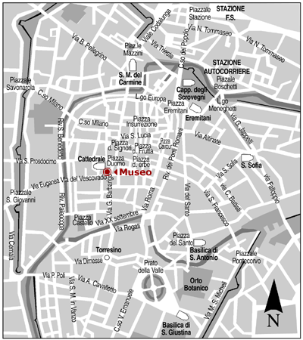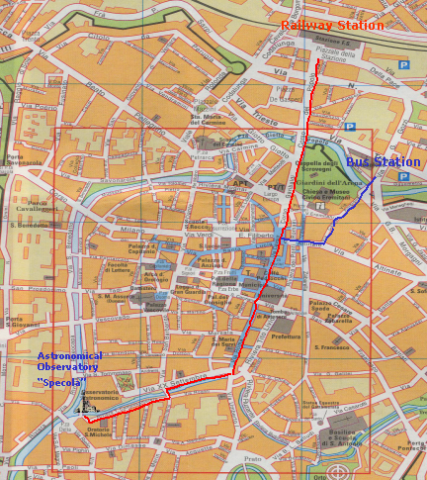
Hotel: Recommended from Obs. Padova

All the hotels accepted to keep a block of rooms reserved to the participants of the meeting for 3 nights starting from the 25th of September, but you have to make the reservations within the 10th of August. All the hotels selected are within 10-20 minutes walking from Piazza Duomo. It is important that when you reserve a room you mention the Osservatorio Astronomico of Padova and my name (Gabriele Cremonese).

Hotel Methis **** Riviera Paleocapa, 70 PADOVA Italy
tel. 049 8725555 fax 049 8725135
E-mail info@methishotel.com Web www.methishotel.com
30 rooms Single room 100 euro, inlc.breakfast
Double as single room 118 euro, inlc. breakfast
Double room 136 euro, inlc. breakfast

Hotel Plaza **** C.so Milano 40 PADOVA Italy
tel. 049 656822 fax 049 661117
E-mail plaza@plazapadova.it Web www.plazapadova.it
20 rooms Single room 115 euro
Double as single room 145 euro
Double room 170 euro

Hotel al Santo *** Via del Santo 147 PADOVA Italy
tel. 049 8752131 fax 049 8788076
E-mail alsanto@alsanto.it Web www.alsanto.it
7 Single room 60 euro, inlc.breakfast
4 Double as single room, 75 euro, inlc. breakfast

Hotel Europa *** Largo Europa 9 PADOVA Italy
tel. 049 661200 fax 049 661508
E-mail hotele@protec.it Web www.hoteleuropapadova.com
15 Single room 119 euro, inlc.breakfast
15 Double room 144 euro, inlc. breakfast

Hotel Giotto *** P.zza Pontecorvo, 33 35100 PADOVA Italy
tel. 049 8761845 fax 049 8364146
Web www.hotelgiotto.com
10 Double as single room 75 euro, incl. breakfast

Hotel Maritan *** Via Gattamelata 34 PADOVA Italy
tel. 049 850177 fax 049 850506
E-mail hotelmaritan@libero.it Web www.hotelmaritan.it
20 Double as single room 75 euro, incl. Breakfast

Casa del Pellegrino ** Via M. Cesarotti 21 PADOVA Italy
tel. 049 8239711 fax 049 8239780
E-mail info@casadelpellegrino.com Web www.casadelpellegrino.com
10 Single room 58 euro
10 Double room 70 euro
Breakfast 6 euro

